**stages at entry (King's vs. MiToS) - barplot, summary statistics**

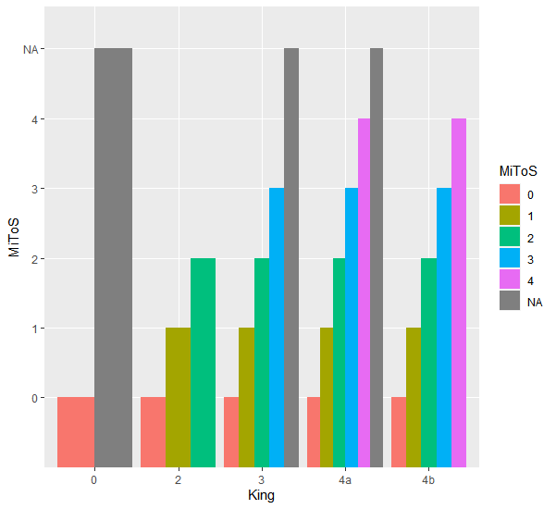

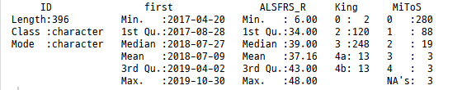

**fu duration (time from first to last alsfrs scores) - histogram, summary statistics**



**Summary of intervals (from first visit to last visit)**

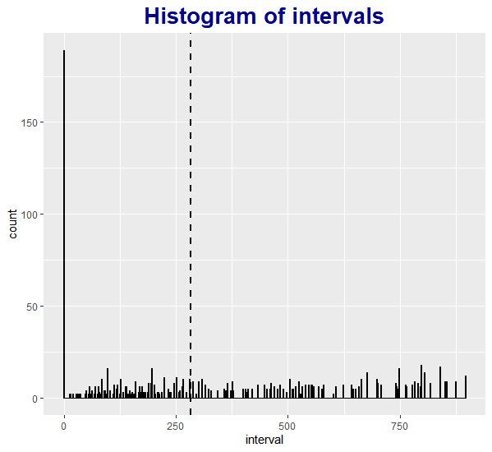

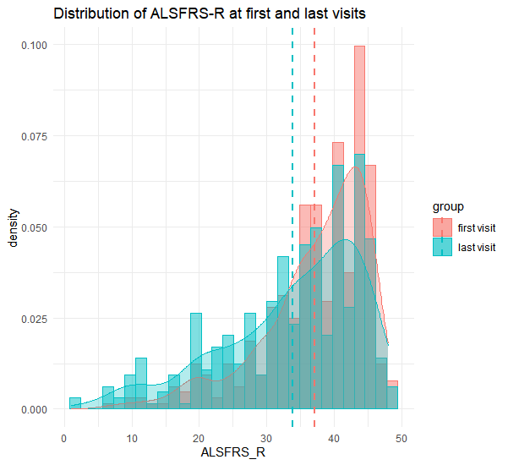

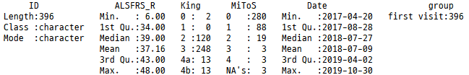

**Summary of First visit ALSFRS-R**

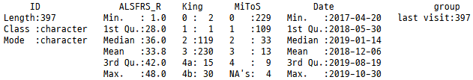

**Summary of Last visit ALSFRS-R**

**progression of ALSFRS total scores over time - line plot, linear regression - comparisons between groups categorized based on the entry stage**